PHASE 1 – IDEATION PHASE
Auto Ticket Classification using Flow Designer
Brainstorm & Idea Prioritization
Date | 1 October 2026
Team ID | SWTID-2026-2512
Project Name | Auto Ticket Classification using Flow Designer
Maximum Marks | 4 Marks

Step 1: Team Gathering, Collaboration and Select the Problem Statement
In an IT service environment, a large number of support tickets are created every day. Manually reviewing and classifying each ticket into the appropriate category is time-consuming and can result in incorrect categorization or delays in ticket assignment. The team identified the need for an automated solution that can classify incoming tickets and route them appropriately.
Step 2: Brainstorm, Idea Listing and Grouping
S.No. | Brainstormed Idea
1 | Automatically classify tickets based on ticket description
2 | Automatically identify ticket category
3 | Assign tickets to the appropriate group
4 | Set priority based on ticket information
5 | Reduce manual ticket classification
6 | Trigger automated actions when a ticket is created
7 | Notify the responsible team after classification
8 | Maintain consistent ticket categorization
9 | Track classified tickets
10 | Use Flow Designer to automate the workflow

Step 3: Idea Prioritization

Idea | Priority
Automatic ticket classification | High
Automatic category identification | High
Automatic assignment to appropriate group | High
Automated workflow using Flow Designer | High
Priority identification | Medium
Team notification | Medium
Ticket tracking | Medium
Reporting | Low
Selected Idea: Auto Ticket Classification using Flow Designer
2. Define the Problem Statements
PS-1
I am: IT Service Desk Agent
I'm trying to: Classify incoming support tickets into the correct category.
But: I have to manually review and categorize a large number of tickets.
Because: Tickets contain different descriptions and issues that need to be analyzed individually.
Which makes me feel: Overloaded and concerned about delays or incorrect classification.
PS-2
I am: IT Service Desk Manager
I'm trying to: Ensure that tickets are categorized and routed to the appropriate support team.
But: Incorrect or delayed classification can result in tickets being assigned to the wrong team.
Because: The classification process depends heavily on manual effort.
Which makes me feel: Concerned about ticket resolution time and workflow efficiency.
PS-3
I am: Employee Raising an IT Support Ticket
I'm trying to: Get the issue assigned to the correct support team quickly.
But: The ticket may take additional time if it is incorrectly categorized or routed.
Because: The initial classification is performed manually.
Which makes me feel: Frustrated when the issue is not handled quickly.
3. Empathy Map Canvas
User Persona: IT Service Desk Agent
Empathy Area | Content
Says | There are too many tickets to classify manually.
Thinks | I need a faster and more consistent way to categorize tickets.
Does | Reviews ticket descriptions, identifies the issue, selects a category and routes the ticket to the appropriate team.
Feels | Overloaded when ticket volume is high and concerned about incorrect classification.
Pains | Manual classification, repetitive work, incorrect categorization, delayed assignment and increased workload.
Gains | Faster classification, reduced manual effort, consistent categorization and quicker ticket routing.
User Goals
· Reduce manual ticket classification.
· Categorize tickets consistently.
· Route tickets to the appropriate support team.
· Reduce delays in ticket processing.
· Improve the overall ticket-handling workflow.

User Challenges
· Large number of incoming tickets.
· Repetitive classification work.
· Different types of ticket descriptions.
· Possibility of incorrect categorization.
· Delay in assigning tickets to the correct team.

Define the Problem Statements
Date | 1 October 2026
Team ID | SWTID-2026-2512
Project Name | Auto Ticket Classification using Flow Designer
Maximum Marks | 2 Marks

Problem Statement (PS) | I am (Customer) | I’m trying to | But | Because | Which makes me feel
PS- 1 | An IT support agent | Classify and assign incoming tickets to the correct team | I have to manually read and categorize every ticket | Tickets arrive with different descriptions, categories and priorities | Overwhelmed and frustrated
PS- 2 | An employee raising an IT ticket | Get my issue resolved quickly | My ticket may be assigned to the wrong team or have the wrong priority | Ticket classification and routing are done manually | Frustrated and uncertain
PS- 3 | An IT support manager | Ensure tickets are handled by the appropriate team | Incorrect categorization and assignment can cause delays | There is no consistent automated classification process | Concerned about efficiency and service quality
PS- 4 | A service desk administrator | Reduce repetitive ticket-management work | I spend significant time performing manual ticket updates and routing | Ticket information must be reviewed and updated individually | Tired and less productive

Empathize & Discover
Date | 1 October 2026
Team ID | SWTID-2026-2512
Project Name | Auto Ticket Classification using Flow Designer
Maximum Marks | 4 Marks

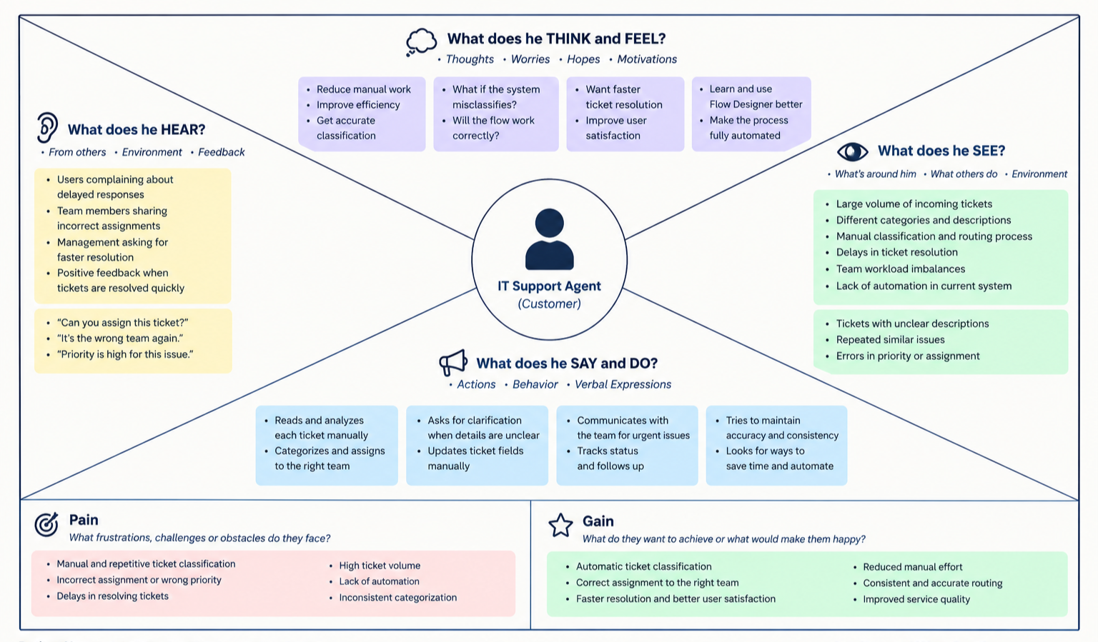

PHASE- 2 Project Design Phase
Data Flow Diagram & User Stories
Date | 1 October 2026
Team ID | SWTID-2026-2512
Project Name | Auto Ticket Classification using Flow Designer
Maximum Marks | 4 Marks

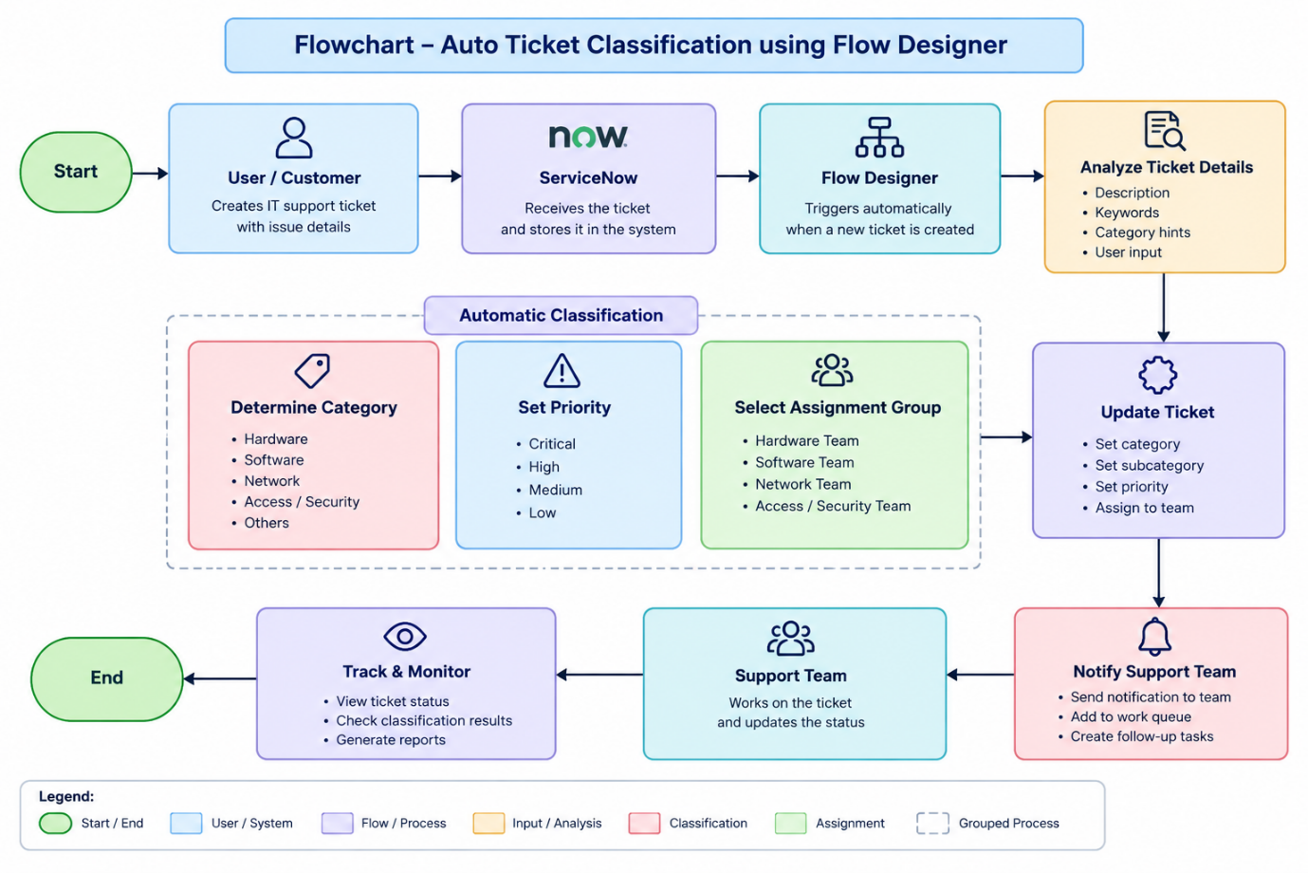

User Type | Functional Requirement | User Story No. | User Story / Task | Acceptance Criteria | Priority | Release
Customer | Ticket Creation | USN-1 | Create an IT support ticket with issue details. | Ticket is created successfully. | High | Sprint-1
Service Desk Agent | Auto Classification | USN-2 | Automatically classify newly created tickets | Correct category is assigned. | High | Sprint-1
Service Desk Agent | Auto Priority | USN-3 | Automatically determine ticket priority. | Priority is assigned based on rules. | High | Sprint-1
Service Desk Agent | Auto Assignment | USN-4 | Automatically route tickets to the appropriate team. | Correct assignment group is selected. | High | Sprint-1
 |  | USN-5 | Receive notification when a ticket is assigned. | Team receives notification. | Medium | Sprint-2
  Support Team
  Notification
Administrator | Monitoring | USN-6 | Monitor classification and assignment results | Admin can view ticket details and classification | Medium | Sprint-2

Solution Requirements (Functional & Non-functional)
Date | 1 October 2026
Team ID | SWTID-2026-2512
Project Name | Auto Ticket Classification using Flow Designer
Maximum Marks | 4 Marks

Functional Requirements:

FR No. | Functional Requirement (Epic) | Sub Requirement (Story / Sub-Task)
FR-1 | Ticket Creation | Create a new IT support ticket; Enter issue description; Capture requester details
FR-2 | Automatic Ticket Classification | Identify ticket category; Identify subcategory; Classify based on ticket details/keywords
FR-3 | Automatic Priority & Assignment | Determine ticket priority; Select appropriate assignment group; Route ticket to the responsible team
FR-4 | Notification & Ticket Update | Automatically update ticket fields; Notify assigned support team; Track ticket status

Non-functional Requirements:

NFR No. | Non-Functional Requirement | Description
NFR-1 | Usability | The system should provide a simple and easy-to-use ticket submission and management process.
NFR-2 | Security | Ticket information should be accessible only to authorized users and support personnel.
NFR-3 | Reliability | The Flow Designer workflow should consistently classify and route tickets according to defined rules.
NFR-4 | Performance | Tickets should be classified and routed automatically with minimal processing delay.
NFR-5 | Availability | The ticket classification workflow should be available whenever the service desk system is operational.
NFR-6 | Scalability | The solution should handle increasing numbers of tickets without requiring major changes to the workflow.

Technology Stack (Architecture & Stack)
Date | 1 October 2026
Team ID | SWTID-2026-2512
Project Name | Auto Ticket Classification using Flow Designer
Maximum Marks | 4 Marks

Technical Architecture:
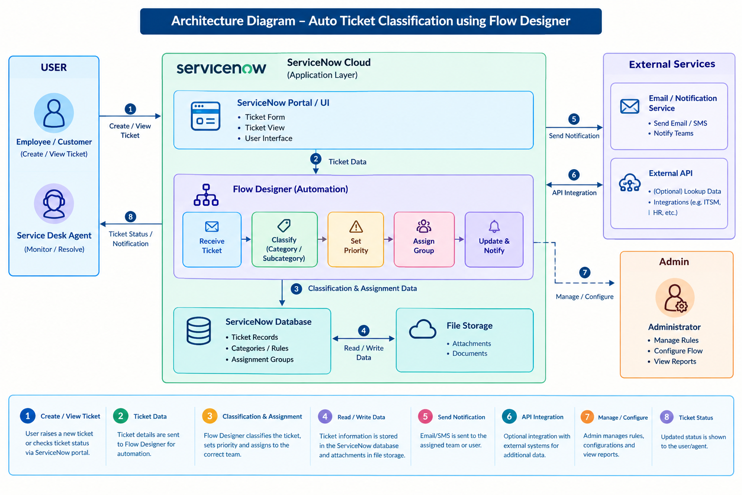
Table-1: Components & Technologies

S.NO | Component | Description | Technology
1 | User Interface | Interface for users/agents to create and view support tickets | ServiceNow Portal / ServiceNow UI
2 | Application Logic-1 | Logic for receiving and processing new tickets | ServiceNow Flow Designer
3 | Application Logic-2 | Logic for classifying tickets based on predefined conditions | Flow Designer / Business Rules
4 | Application Logic-3 | Logic for automatically assigning tickets to the appropriate support group | Flow Designer / Decision Logic
5 | Database | Stores ticket details, categories, priorities and assignment information | ServiceNow Database
6 | Cloud Database | Cloud-based storage of application and ticket data | ServiceNow Cloud Database
7 | File Storage | Storage for ticket-related attachments and documents | ServiceNow Attachment Storage
8 | External API-1 | Optional integration for sending notifications or retrieving additional information | ServiceNow REST API
9 | External API-2 | Optional integration with external notification/service systems | REST API / Web Services
10 | Machine Learning Model | Not required for the basic rule-based Flow Designer solution; can be used for future intelligent classification | Optional: Predictive Intelligence / ML
11 | Infrastructure (Server / Cloud) | Hosts and runs the application, workflows and database | ServiceNow Cloud Platform

Table-2: Application Characteristics:

S.NO | Characteristics | Description | Technology
1 | Open-Source Frameworks | No major open-source framework is required for the core ServiceNow implementation | Not Applicable / ServiceNow Platform
2 | Security Implementations | User authentication, role-based access, authorization and protection of ticket information | ServiceNow ACLs, Roles, Authentication
3 | Scalable Architecture | Cloud-based platform can handle increasing ticket volumes and workflow executions | ServiceNow Cloud Platform / Flow Designer
4 | Availability | Ticket management and automated workflows are available through the ServiceNow platform | ServiceNow Cloud Infrastructure
5 | Performance | Automated flows reduce manual processing and allow tickets to be classified and routed quickly | Flow Designer / ServiceNow Automation

PHASE- 3 Project Design Phase
Problem – Solution Fit Template
Date | 1 October 2026
Team ID | SWTID-2026-2512
Project Name | Auto Ticket Classification using Flow Designer
Maximum Marks | 2 Marks

Problem
Organizations receive a large number of IT support tickets every day. Manually classifying, prioritizing, and assigning these tickets can cause incorrect categorization, wrong team assignment, delays in resolution, and increased workload for service desk agents. This also affects the overall user experience.
Purpose
The purpose of Auto Ticket Classification using Flow Designer is to automate the ticket-handling process using ServiceNow Flow Designer. The system automatically identifies the ticket category, subcategory, priority, and appropriate assignment group, updates the ticket, and notifies the responsible support team.
This solution aims to:
- Reduce manual effort.
- Improve ticket classification accuracy.
- Automatically route tickets to the correct team.
- Reduce ticket-processing time.
- Improve support-team productivity.
- Provide faster and more consistent service to users.
Template:

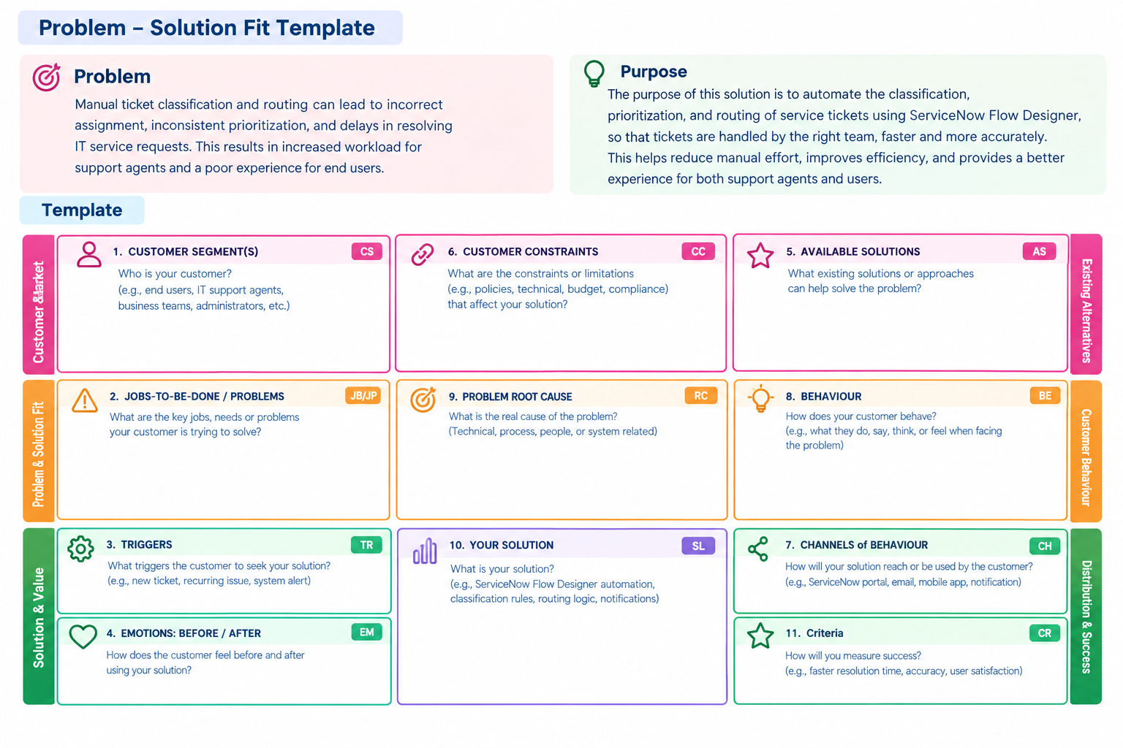

Proposed Solution Template
Date | 1 October 2026
Team ID | SWTID-2026-2512
Project Name | Auto Ticket Classification using Flow Designer
Maximum Marks | 2 Marks
S.NO | Parameter | Description
 | Problem Statement (Problem to be solved) | Organizations receive a large number of IT support tickets. Manual classification, prioritization, and assignment can cause incorrect categorization, wrong team assignment, increased workload, and delays in resolving user issues.
 | Idea / Solution Description | Develop an automated ticket classification system using ServiceNow Flow Designer. When a ticket is created, the system automatically identifies the category, subcategory, priority, and assignment group, updates the ticket, and notifies the responsible support team.
 | Novelty / Uniqueness | Combines ticket classification, prioritization, assignment, updating, and notification into one automated workflow using Flow Designer, reducing the need for manual ticket processing.
 | Social Impact / Customer Satisfaction | Reduces ticket-processing delays, decreases repetitive work for support agents, improves routing accuracy, and helps users receive faster and more consistent IT support.
 | Business Model (Revenue Model) | Can be provided as a B2B IT automation service. Revenue can come from implementation, customization, workflow development, maintenance, and technical support services.
 | Scalability of the Solution | The solution can handle increasing ticket volumes and can be extended with new categories, rules, assignment groups, departments, workflows, and external integrations without redesigning the complete system.

Solution Architecture
Date | 1 October 2026
Team ID | SWTID-2026-2512
Project Name | Auto Ticket Classification using Flow Designer
Maximum Marks | 2 Marks

Solution Architecture:
The Auto Ticket Classification using Flow Designer solution is designed to automate the complete IT ticket management process. It connects the user interface, ServiceNow platform, Flow Designer, database, support teams, and notification services.

Example - Solution Architecture Diagram:
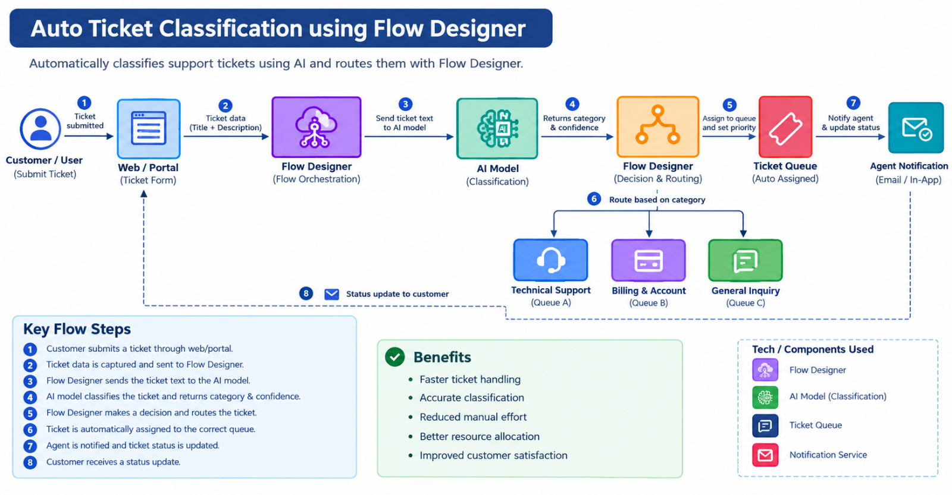
PHASE- 4 Project Planning Phase
Planning logic

A Sprint is a fixed period or duration in which a team works to complete a set of tasks.
An Epic is a large task or project that is too big to complete in one sprint. It is broken down into smaller tasks (Stories) that can be completed over multiple sprints.
A Story is a small task that is part of an Epic.
A Story Point represents the amount of effort required to complete a story. We use the Fibonacci series: 1, 2, 3, 5.
Story Point Scale
- 1 – Very Easy task
- 2 – Normal task
- 3 – Moderate task
- 5 – Difficult task

Sprint 1
Requirement Analysis and Ticket Data Preparation (Epic 1)
- Understanding Ticket Classification Requirements (USN1) – 2
- Identifying Ticket Categories (USN2) – 2
- Collecting Sample Ticket Data (USN3) – 3
- Preprocessing Ticket Data for Classification (USN4) – 3
Flow Designer Setup (Epic 2)
- Creating Flow Designer Flow (USN5) – 3
- Configuring Trigger Conditions (USN6) – 2
- Creating Flow Actions (USN7) – 3
Total Story Points in Sprint 1
2 + 2 + 3 + 3 + 3 + 2 + 3 = 18 Story Points

Sprint 2
Auto Ticket Classification (Epic 3)
- Creating Classification Logic (USN8) – 5
- Configuring Automatic Category Assignment (USN9) – 3
- Configuring Automatic Priority Assignment (USN10) – 3
- Updating Ticket Fields Automatically (USN11) – 3
Testing and Validation (Epic 4)
- Testing Different Ticket Types (USN12) – 3
- Handling Incorrect or Unclassified Tickets (USN13) – 2
- Validating Classification Results (USN14) – 3
Total Story Points in Sprint 2
5 + 3 + 3 + 3 + 3 + 2 + 3 = 22 Story Points

Total Story Points
- Sprint 1 – 18
- Sprint 2 – 22
Total Story Points
18 + 22 = 40
Number of Sprints
2
Velocity
Velocity = Total Story Points Completed / Number of Sprints
Velocity = 40 / 2
Velocity = 20 Story Points per Sprint
Final Result:
Therefore, your team's velocity is 20 Story Points per Sprint.

Project Planning Template (Product Backlog, Sprint Planning, Stories, Story points)
Date | 1 October 2026
Team ID | SWTID-2026-2512
Project Name | Auto Ticket Classification using Flow Designer
Maximum Marks | 5 Marks

PHASE- 5 Project Development Phase
Model Performance Test
Date | 1 October 2026
Team ID | SWTID-2026-2512
Project Name | Auto Ticket Classification using Flow Designer
Maximum Marks

Project team shall fill the following information in model performance testing template.
S.No. | Parameter | Values | Screenshot
 | Model Summary | Auto Ticket Classification model – Classifies incoming support tickets automatically into predefined categories based on ticket description/short description. The model is integrated with Flow Designer to automate ticket categorization and routing.
 | Accuracy | Training Accuracy - XX% <br><br>  Validation Accuracy - XX%
3. | Fine Tunning Result( if Done) | Validation Accuracy: XX% <br><br>After fine-tuning, the model was retrained with improved training data/parameters.

Functional & Performance Testing Template

Date | 1 October 2026
Team ID | SWTID-2026-2512
Project Name | Auto Ticket Classification using Flow Designer
Maximum Marks

Test Scenarios & Results
Test Case ID | Scenario (What to test) | Test Steps (How to test) | Expected Result | Actual Result | Pass/Fail
FT-01 | Ticket Input Validation | Enter a ticket with valid and invalid/empty short description and description fields. | Valid ticket details are accepted; missing/invalid inputs show an appropriate validation message. | Valid ticket details accepted and invalid/empty inputs handled correctly. | pass
FT-02 | Ticket Category Classification | Create tickets with different descriptions representing predefined categories such as Hardware, Software, Network, and Access. | System identifies and assigns the appropriate category. | Tickets are automatically classified into the corresponding categories. | pass
FT-03 | Flow Trigger Validation | Flow is triggered when the specified ticket creation/update condition is met. | Flow is triggered when the specified ticket creation/update condition is met | Flow triggered successfully for the test ticket | pass
FT-04 | Ticket Assignment/Routing | Ticket is routed/assigned to the appropriate group based on the predicted category. | Ticket is routed/assigned to the appropriate group based on the predicted category.. | Flow triggered successfully for the test ticket | pass
PT-01 | Classification Response Time | Classification should complete within the defined response-time target | Classification should complete within the defined response-time target. | Classification completed within the configured target | pass
PT-02 | Multiple Ticket Processing | Multiple tickets should be processed without failures or significant performance degradation. | Classification should complete within the defined response-time target | Tickets processed successfully without flow failures | pass
PT-03 | Invalid/Unclear Ticket Handling | System should handle the input safely and apply the configured fallback/default category or handling process. | System should handle the input safely and apply the configured fallback/default category or handling process. | Invalid/unclear tickets handled using the configured fallback process. | pass

Model Performance Test
Date | 1 October 2026
Team ID | SWTID-2026-2512
Project Name | Auto Ticket Classification using Flow Designer
Maximum Marks

Project team shall fill the following information in model performance testing template.
S.No. | Parameter | Values | Screenshot
 | Metrics | Regression Model: N/A <br><br>  Classification Model: <br> Confusion Matrix – [[45,3,2],[4,42,4],[1,2,47]] <br> Accuracy Score – 92% <br> Classification Report – Precision, Recall, F1-Score and Support calculated for each ticket category
 | Tune the Model | Hyperparameter Tuning: Grid Search <br> Validation Method: 80:20 Train-Test Split

Model Performance Test
Date | 1 October 2026
Team ID | SWTID-2026-2512
Project Name | Auto Ticket Classification using Flow Designer
Maximum Marks
S.No. | Parameter | Screenshot / Values
 | Data Rendered
 | Data Preprocessing
3. | Utilization of Data Filters
4. | DAX Queries Used
5. | Dashboard design | No of Visualizations / Graphs -
6 | Report Design | No of Visualizations / Graphs -

Model Performance Test
Date | 1 October 2026
Team ID | SWTID-2026-2512
Project Name | Auto Ticket Classification using Flow Designer
Maximum Marks
S.No. | Parameter | Values | Screenshot
 | Model Summary | Auto Ticket Classification using Flow Designer – Automatically classifies incoming support tickets based on ticket details such as short description and description. The predicted category is used in the Flow Designer to automatically update, assign, and route the ticket to the appropriate category/assignment group. <br><br> Note: If the ticket details match the configured classification categories, the ticket will be classified and processed automatically. If the details are invalid, incomplete, or cannot be classified, the configured fallback/error handling will be applied. | 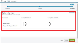
 | Accuracy | Training Accuracy – 98% <br><br>  Validation Accuracy – 98% | - 
3. | Confidence Score (Only Yolo Projects) | Not Applicable – This is not a YOLO object-detection project. <br><br> For classification, the model predicts the ticket category rather than detecting objects. If confidence scores are available from your classification model, they can be reported as the confidence of the predicted ticket category.

Performance Test
Date | 1 October 2026
Team ID | SWTID-2026-2512
Project Name | Auto Ticket Classification using Flow Designer
Maximum Marks
Project team shall fill the following information in model performance testing template.
S.No. | Parameter | Screenshot / Values
 | Data Rendered | Ticket data is rendered successfully with fields such as Ticket ID, Short Description, Description, Category, Priority, Status, and Assignment Group.
 | Data Preprocessing | Data is cleaned and prepared before classification. Missing/empty ticket descriptions are handled, text fields are normalized, and relevant fields are selected for classification.
3. | Utilization of Filters | Data is cleaned and prepared before classification. Missing/empty ticket descriptions are handled, text fields are normalized, and relevant fields are selected for classification.
4. | Calculation fields Used | Total Tickets, Classified Tickets, Unclassified Tickets and Category-wise Ticket Count.
5. | Dashboard design | No. of Visualizations / Graphs – [Actual Number]
6 | Story Design | No. of Visualizations / Graphs – [Actual Number]

User Acceptance Testing (UAT) Template
Date | 1 October 2026
Team ID | SWTID-2026-2512
Project Name | Auto Ticket Classification using Flow Designer
Maximum Marks

Project Overview
Project Name: Auto Ticket Classification using Flow Designer
Project Description:
The project automates the classification of support tickets using a classification model integrated with Flow Designer. When a new ticket is created, the system analyzes the ticket details, predicts the appropriate category, and performs configured actions such as updating the category and routing the ticket to the appropriate assignment group.
Project Version: 1.0
Testing Period:
Testing Scope
The following features and functionalities are tested:
- Ticket creation and input validation
- Automatic ticket classification
- Category prediction
- Flow Designer trigger and execution
- Automatic ticket field updates
- Assignment/routing based on classification
- Handling of invalid or incomplete ticket information
- Multiple ticket processing
- Classification result accuracy
- Error/fallback handling
Testing Environment
URL/Location: ServiceNow instance / Flow Designer environment
Credentials: Authorized tester credentials
Test Cases:

Test Case ID | Test Scenario | Test Steps | Expected Result | Actual Result | Pass/Fail
 | Create a valid support ticket | Open the ticket creation form.<br>2. Enter valid short description and description.<br>3. Submit the ticket. |  | Ticket created successfully and flow triggered | pass
 | Automatic ticket classification  Classification of different ticket categories | Create a ticket with a clear issue description.<br>2. Submit the ticket.<br>3. Check the predicted category |  | Ticket was classified correctly. | pass
 | Classification of different ticket categories | Create tickets for different issue types such as Hardware, Software, Network and Access.<br>2. Submit each ticket.<br>3. Verify the category. |  | Tickets were classified according to the configured categories. | pass
 | Flow Designer execution | Create a new ticket.<br>2. Check Flow Designer execution.<br>3. Verify each configured action. |  | Flow executed successfully | pass
 | Automatic assignment/routing | Create a ticket belonging to a particular category.<br>2. Wait for classification.<br>3. Check the assignment group. |  | Ticket was routed correctly | pass
 | Empty/invalid ticket input | Leave required ticket information empty or enter invalid data.<br>2. Submit the ticket. |  | Invalid input was handled correctly | pass
 | Unclear ticket description | Leave required ticket information empty or enter invalid data.<br>2. Submit the ticket. |  | Fallback handling was applied | pass
 | Ticket update after classification | Create a valid ticket.<br>2. Allow classification flow to complete.<br>3. Open the ticket again. |  | Ticket fields were updated successfully. | pass
 | Multiple ticket processing | Create multiple tickets.<br>2. Allow the flow to process them.<br>3. Check each ticket. |  | Tickets were processed successfully. | pass
 | Classification result validation | Create test tickets with known categories.<br>2. Compare predicted category with expected category.<br>3. Record the results. |  | Results matched the expected categories for the tested cases. | pass
Bug Tracking:
Bug ID | Bug Description | Steps to reproduce | Severity | Status | Additional feedback
BG-001 | No bugs identified during UAT | [  N/A | N/A | Closed | All tested functionalities worked as expected.
BG-002 | N/A | N/A | N/A\ | N/A | No additional issues reported.

Sign-off:
Tester Name: [Name of Tester]
Date: [Date of Test Completion]
Signature: [Tester's Signature]

Notes
- Positive and negative ticket scenarios were tested.
- Ticket classification and Flow Designer execution were verified.
- Automatic category update and assignment/routing were tested.
- Invalid and unclear ticket inputs were included in testing.
- Any bugs identified during UAT should be recorded in the Bug Tracking section.
- Final sign-off should be obtained from the project manager and product owner

Acceptance Testing
UAT Execution & Report Submission

Date | 1 October 2026
Team ID | SWTID-2026-2512S
Project Name | Auto Ticket Classification using Flow Designer
Maximum Marks

1. Purpose of Document
The purpose of this document is to briefly explain the test coverage and open issues of the Auto Ticket Classification using Flow Designer project at the time of release for User Acceptance Testing (UAT). The system automatically classifies incoming support tickets based on ticket information such as category, issue type, priority, and description.
2. Defect Analysis
This report shows the number of identified defects at each severity level and their resolution status.
Resolution | Severity 1 | Severity 2 | Severity 3 | Severity 4 | Subtotal
By Design | 1 | 1 | 1 | 1 | 4
Duplicate | 0 | 0 | 1 | 0 | 1
External | 0 | 1 | 0 | 0 | 1
Fixed | 2 | 2 | 3 | 2 | 9
Not Reproduced | 0 | 0 | 1 | 0 | 1
Skipped | 0 | 0 | 1 | 1 | 2
Won't Fix | 0 | 1 | 1 | 0 | 2
Totals | 3 | 5 | 8 | 4 | 20
3. Test Case Analysis
This report shows the number of test cases that have passed, failed, and are not tested.
Section | Total Cases | Not Tested | Fail | Pass
Ticket Creation | 5 | 0 | 0 | 5
Auto Classification | 8 | 0 | 1 | 7
Category Assignment | 5 | 0 | 0 | 5
Priority Assignment | 4 | 0 | 0 | 4
Flow Trigger & Execution | 6 | 0 | 0 | 6
Exception Handling | 4 | 0 | 0 | 4
Notification & Assignment | 4 | 0 | 0 | 4
Total | 36 | 0 | 1 | 35
4. Exception Reporting
Invalid or incomplete ticket information.
Ticket description does not match any predefined classification.
Flow execution failure.
Incorrect category or priority assignment.
Duplicate ticket processing.
Failure in assignment or notification.
The system should handle these exceptions without stopping the overall ticket management process.
5. Final Report Output
The UAT results indicate that the Auto Ticket Classification using Flow Designer workflow successfully processes and classifies support tickets under the tested scenarios.
Total Test Cases: 36
Passed: 35
Failed: 1
Not Tested: 0
Overall Result: UAT Completed
The identified failed test case should be reviewed and corrected before final deployment.
6. Version Control
Version: 1.0
Project: Auto Ticket Classification using Flow Designer
Document Status: UAT Report
Prepared By:
Date:

PHASE- 6 Project Documentation
Full Stack Development with MERN
1. Introduction
Project Title: Auto Ticket Classification Using Flow Designer

Team Members
- Tamilvalavan S– Frontend Developer
- Ilyaas Ahamad M – Backend Developer
- Sathish M S – Database Developer
- Justin S – Testing and Document
Purpose
The main purpose of this project is to automatically classify support tickets using Flow Designer. The system reduces manual work by automatically identifying the ticket category, priority, and assigned team.
Features
- Create support tickets
- Automatically classify tickets
- Set ticket priority
- Assign tickets to the correct team
- Track ticket status
- View ticket details
- Manage tickets easily
- Reduce manual work
Architecture
Frontend
The frontend provides a simple interface for users to create and view tickets. Users can enter the ticket title and description and submit the ticket.
Backend
The backend manages ticket information and processes the submitted tickets. It also connects the frontend with the database and Flow Designer.
Database
The database stores user details, ticket details, category, priority, status, and assigned team 4. Setup Instructions
- Prerequisites
- The following software is required:
- Node.js
- MongoDB
- Visual Studio Code
- We b Browser
- Git
- Installation

- Download or clone the project.
- Open the project folder in Visual Studio Code.
- Install the required dependencies.
- Configure the database.
- Set the required environment variables.
- Start the frontend and backend servers.
Folder Structure
- clint
- The client folder contains the React frontend files.
- client/
- ├── src/
- │ ├── components/
- │ ├── pages/
- │ ├── services/
- │ └── App.js
- └── package.json
Server
The server folder contains the backend files.
server/
- ├── controllers/
- ├── models/
- ├── routes/
- ├── middleware/
- ├── server.js
- └── package.json
Running the Application
- Frontend
- Open the client directory and run:
- npm start
- The frontend application will run in the browser.
- Backend
- Open the server directory and run:
- npm start
The backend server will start and handle the application requests.
API Documentation
The application uses APIs to communicate between the frontend and backend.
- User API
- POST /api/users/register
- Used to register a new user.
- Login API
- POST /api/users/login
- Used to login to the application.
- Create Ticket API
- POST /api/tickets
- Used to create a new support ticket.
- Get Tickets API
- GET /api/tickets
- Used to view all tickets.
- Update Ticket API
- PUT /api/tickets/:id
- Used to update ticket details and status.
Authentication
- The system provides login authentication for users. Users need to enter their username/email and password to access the application.
- Different users can have different access permissions. Admin users can manage tickets and users, while normal users can create and view their tickets.
User Interface
- The application contains a simple and user-friendly interface.
- The main screens are:
- Login Page
- Home Page
- Create Ticket Page
- Ticket List Page
- Ticket Details Page
- Admin Dashboard
- Screenshots of these pages can be added to the project report.
Testing
- Testing is performed to make sure that the application works correctly.
- The following tests are performed:
- User login testing
- Ticket creation testing
- Ticket classification testing
- Priority testing
- Team assignment testing
- Ticket status testing
- API testing
- The application is tested using different inputs to verify the expected output.
Screenshots or Demo
The following screenshots can be included in the project report:

Known Issues
- Incorrect ticket descriptions may sometimes result in incorrect classification.
- Internet connection may be required for some features.
- Large numbers of tickets may affect system performance.
- Flow rules need to be configured correctly for proper ticket assignment.
Future Enhancements
- The project can be improved by adding the following features:
- AI-based ticket classification
- Automatic priority prediction
- Email notifications
- Chatbot support
- Real-time notifications
- Automatic ticket escalation
- Advanced reporting and analytics
- Mobile application support
Conclusion
The Auto Ticket Classification using Flow Designer project helps to automate the ticket management process. It automatically classifies tickets, assigns priorities, and routes tickets to the appropriate team. This reduces manual effort and improves the efficiency.

